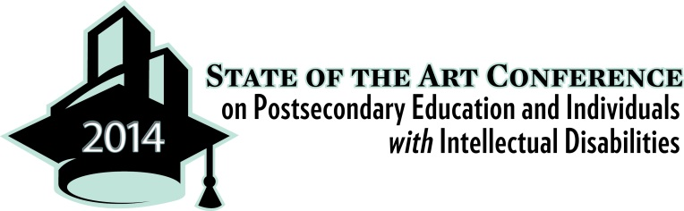

Thank you very much for your interest in attending the 2014 State of the Art Conference on Postsecondary Education and Individuals with Intellectuals Disabilities. We are so pleased that you have registered, and we look forward to meeting you in November.

We do have limited scholarship funds, and would like to offer them to worthy individuals. There will be open enrollment while these funds are available. Please answer the following questions, and return this form—with your name in the title—to Rachel Korpan Lee at rkorpant@gmu.edu.

Name(s) of attendee(s) for whom you are seeking registration fee scholarship assistance:

1) Have you requested financial support from any organizations or your state Development Disabilities Council? If so, are any funds being provided?

2) Will you be incurring travel and hotel expenses? If so, what is the total estimated travel costs for you and any family members who will be attending?

3) Do you plan on sharing the information with others? If so, how and with whom?

4) How much scholarship are you requesting? (Registration is $400 prior to October 15th)

